**Khai Phan Thanh (100901164)**

**DPS918 – Unix Programming**

**Question 1)**

* **Source Code**

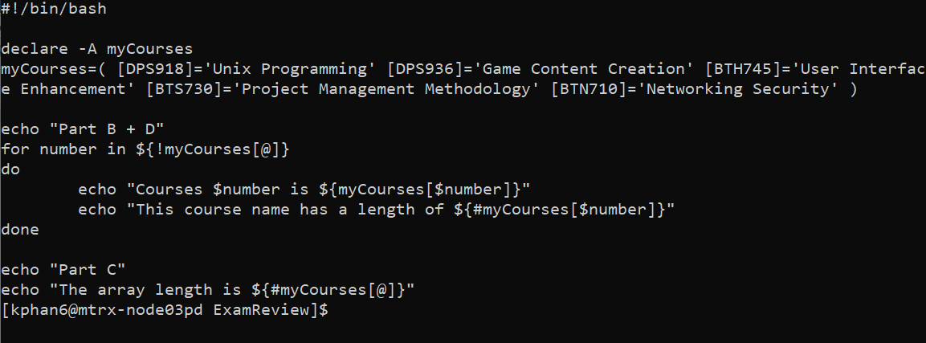

* **Result**

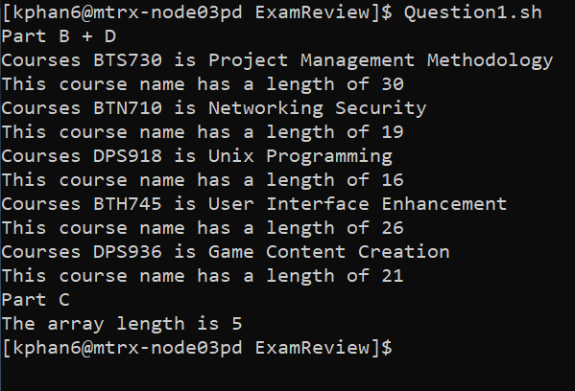

**Question 2)**

* **Source Code**

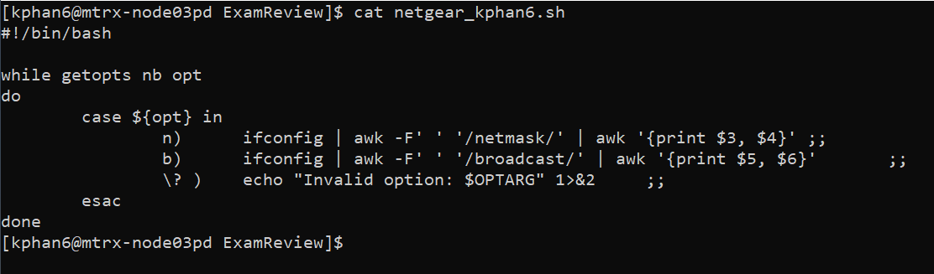

* **Netgear_kphan6.sh -a**

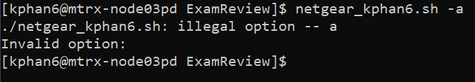

* **Netgear_kphan6.sh -b**

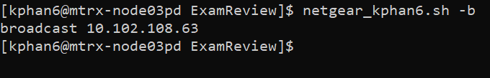

* **Netgear_kphan6.sh -n**

